Day 07 – Linux File System Hierarchy & Scenario-Based Practice
/ :
It’s a top level directory in linux. Everything in linux starts with root /. Including all files, folders and devices.
/home: User files – Each user gets their personal folder inside /home
/root: home directory of root user
/etc: system-wide Configuration files (/etc/hosts, /etc/passwd, /etc/ssh, etc/systemd )
-Many commands and applications read settings from /etc.
-Usually requires sudo to modify files.
/bin: essential commands
Stores critical commands needed during:
- system boot
- single-user mode
- basic system operation
/var: logs & variable data
It stores files that change frequently while the system is running.
Examples include:
- logs
- cache
- mail
- spool files
- temporary service data
/var/log
/var/log/syslog – General System log
/var/log/auth.log – Login & Authentication log
/var/log/kern.log – Kernel log
/var/log/dpkg.log – package installation log
/var/log/nginx/ - nginx server log

Read log file: cat /var/log/syslog
View recent lines: tail /var/log/syslog
Watch logs in real time: tail -f /var/log/syslog
e.g
If nginx is failing, check: cat /var/log/nginx/error.log
Watch log in real time
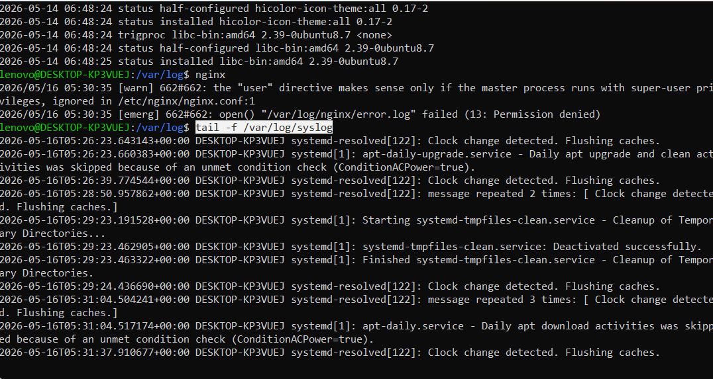
Part 2: Scenario-Based Practice (40 minutes)
Question: How do you check if the 'nginx' service is running?
Step 1: Check service status - systemctl status nginx
Step 2: If service is not found, list all services – systemctl list-units --type=service
Step 3: Check if service is enabled on boot – systemctl is --enabled nginx (To know if it will start automatically run after reboot)

Scenario 1: Service Not Starting
A web application service called 'myapp' failed to start after a server reboot.
What commands would you run to diagnose the issue?
Write at least 4 commands in order.

- First check: Is the service running or failed?
Checking service status - systemctl status myapp
- Then check: What do the logs say?
Checking logs - journalctl -u myapp -n 50
Checking live logs - journalctl -u myapp -f
Checking system logs - sudo tail -n 50 /var/log/syslog (for boot-related issue, dependency failure, permission problem)
- Verify if the service process is running
Ps aux | grep nginx (Checks whether the process started or immediately crashed)

- Finally check: Is it enabled to start on boot?
systemctl is-enabled nginx – checking service is automatically run after reboot
- Try restarting manually
Sudo systemctl restart myapp –
Then re-check status

Scenario 2: High CPU Usage
Your manager reports that the application server is slow. You SSH into the server. What commands would you run to identify. which process is using high CPU?
1.top
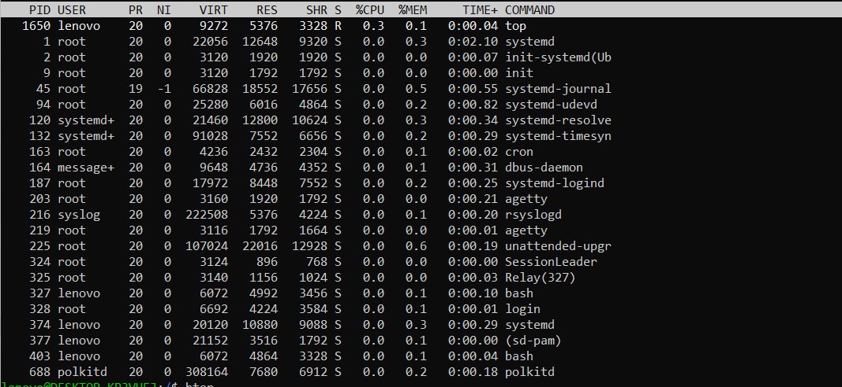
2.ps aux –sort=-%cpu | head -10
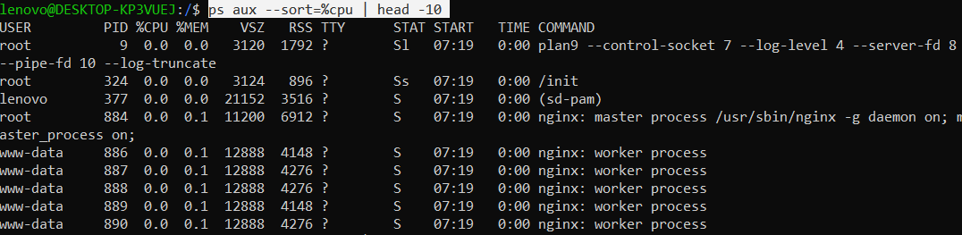
3.Get details of specific PID
ps -p 45 -o pid,ppid,cmd,%cpu,%mem
Scenario 3: Finding Service Logs
A developer asks: "Where are the logs for the 'docker' service?" The service is managed by systemd. What commands would you use?

Scenario 4: File Permissions Issue
